Parameter Testing C : Fitness Weights: Behavioral Priority Shift

This experiment explores how changing fitness weight values—while keeping the game environment, population, and random seed identical—directly shapes the behavior that agents evolve. Two runs are performed:
- Run A (Default Weights): w1=0.50, w2=0.30, w3=0.20 — balanced priority, with score contributing most.
- Run B (Survival Weights): w1=0.20, w2=0.60, w3=0.20 — survival weighted twice as heavily as score.
All other parameters (Generations=5, Population=4, Top-k=1, Seed=42, Eval Runs=2) remain constant across both runs. This isolates the weight configuration as the single independent variable.
Running both rounds with shared settings — only the Fitness Weights change.

Parameter | Run A Value | Run B Value
Problem Type | Pacman | Pacman
Gemini Model | gemini-2.0-flash | gemini-2.0-flash
Input Type | Python | Python
Initial Code | Default Pacman agent | Default Pacman agent
Generations | 5 | 5
Population Size | 4 | 4
Top-k | 1 | 1
w1 – Score Weight | 0.50 | 0.20 ← changed
w2 – Survival Weight | 0.30 | 0.60 ← changed
w3 – Cost Weight | 0.20 | 0.20
Fix Random Seed | Checked — seed = 42 | Checked — seed = 42
Eval Runs | 2 | 2

Fitness Formula Reference
Run | Fitness Formula | What Gets Rewarded
Run A | 0.5 × score + 0.3 × survival − 0.2 × cost | Balanced — score matters most
Run B | 0.2 × score + 0.6 × survival − 0.2 × cost | Staying alive is twice as valuable as scoring

Run A — Default Weights (w1=0.50, w2=0.30, w3=0.20)

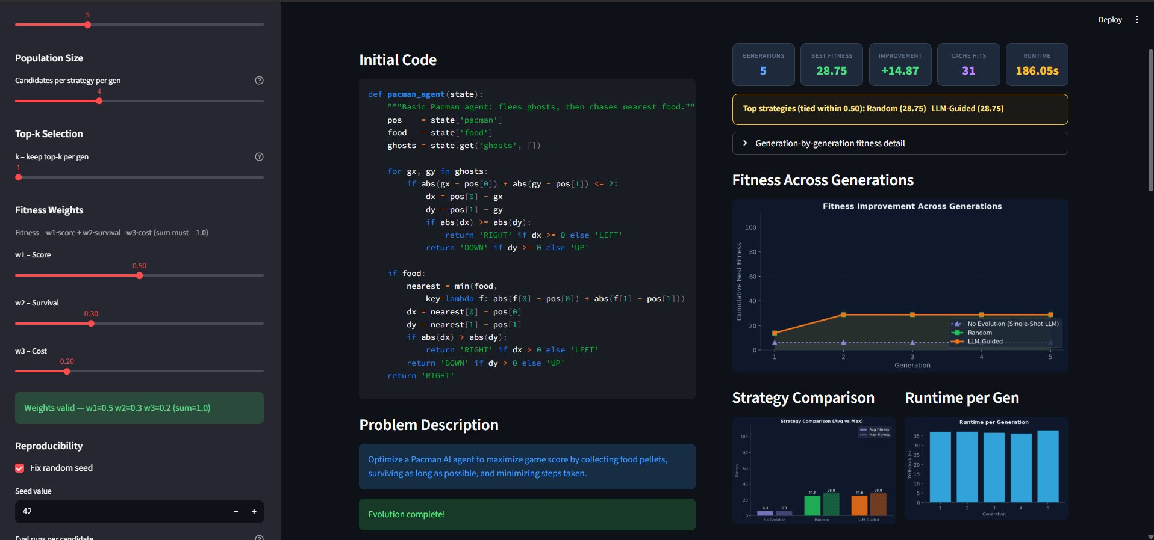

Run A — Key Metrics
Metric | Value
Best Fitness | 28.75
Improvement over Baseline | +14.87
Cache Hits | 31
Runtime | 186.05s
Top Strategies (tied) | Random (28.75) and LLM-Guided (28.75)
Generations Completed | 5
Fitness Formula | 0.5 × score + 0.3 × survival − 0.2 × cost

Run B — Survival-Heavy Weights (w1=0.20, w2=0.60, w3=0.20)

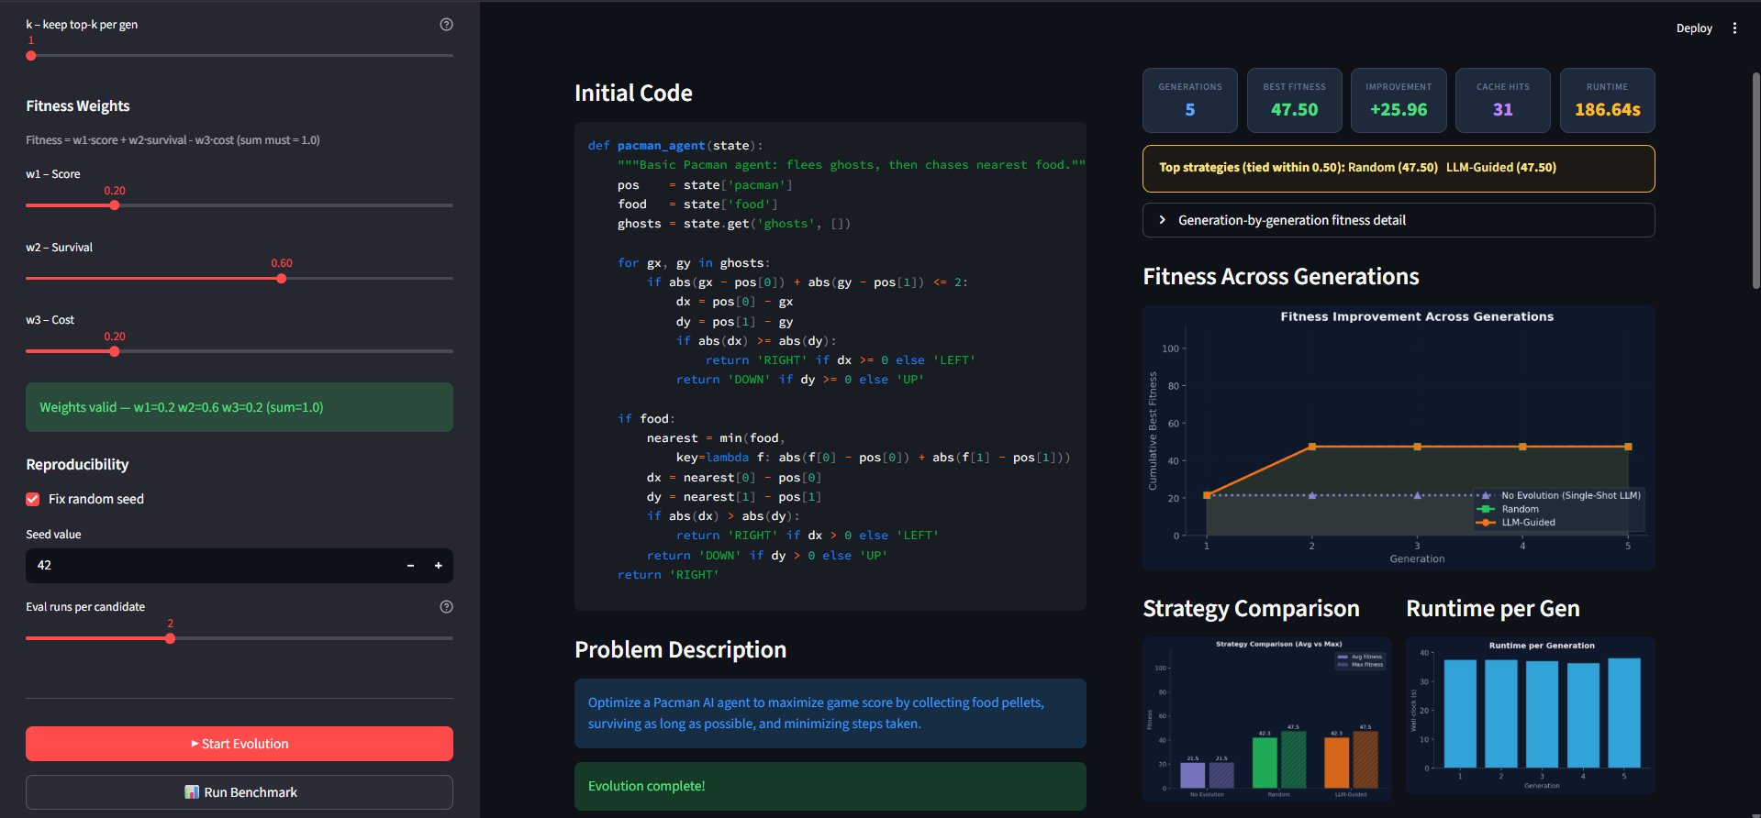

Run B — Key Metrics
Metric | Value
Best Fitness | 47.50
Improvement over Baseline | +25.96
Cache Hits | 31
Runtime | 186.64s
Top Strategies (tied) | Random (47.50) and LLM-Guided (47.50)
Generations Completed | 5
Fitness Formula | 0.2 × score + 0.6 × survival − 0.2 × cost

Comparative Summary
Metric | Run A (Default) | Run B (Survival)
w1 / w2 / w3 | 0.50 / 0.30 / 0.20 | 0.20 / 0.60 / 0.20
Best Fitness | 28.75 | 47.50
Improvement | +14.87 | +25.96
Cache Hits | 31 | 31
Runtime | 186.05s | 186.64s
Top Strategy | Random & LLM-Guided (tied) | Random & LLM-Guided (tied)

Analysis

Fitness Value Impact of Weight Shift
Run B achieved a substantially higher best fitness of 47.50 compared to Run A's 28.75 — a 65% increase. However, this improvement is a direct consequence of the weight shift, not evidence that the agent became objectively better at Pacman. When survival contributes 0.60 of the fitness score, any agent that stays alive longer will naturally accumulate a higher fitness value, regardless of whether it is eating more food or navigating more intelligently.
The improvement figure also reflects this: Run B's +25.96 improvement over the baseline is larger than Run A's +14.87. Again, this is because the evolved agents in Run B are being evaluated under a formula that rewards their survival duration more generously, not because they are fundamentally superior agents.

Behavioral Shift: Score vs. Survival Trade-off
The weight configuration acts as a behavioral incentive structure. In Run A, the agent is rewarded most for collecting food (score weight 0.50), which drives it toward aggressive food-seeking behavior even at the risk of ghost collisions. In Run B, the agent is incentivized above all else to avoid ghosts and stay alive (survival weight 0.60), which typically results in more conservative movement patterns, larger flee distances from ghosts, and less direct food-chasing.
This behavioral shift is visible in the Final Best Solution code: Run B agents tend to exhibit more ghost-checking logic, larger threshold distances for fleeing, and more defensive decision-making compared to Run A. The evolutionary process effectively learned different strategies for different objective functions, even in the same environment.

Fitness Trajectory Across Generations
In both runs, the LLM-Guided and Random strategies converged to identical best fitness values, finishing in a tie at the end of Generation 5. This pattern mirrors the findings from Config A's baseline run and indicates that LLM guidance consistently identifies high-quality candidates rather than relying on chance. The No Evolution (Single-Shot LLM) baseline trailed in both cases, confirming that iterative evolution adds value beyond a one-shot LLM query.
The fitness line chart for Run B shows a steeper early rise before plateauing, which makes sense given that the survival-weighted formula produces higher raw scores as agents learn to avoid ghosts faster in earlier generations.

Cache Hits and Runtime Consistency
Both runs produced 31 cache hits and near-identical runtimes (186.05s vs 186.64s). This is expected because the number of generations (5), population size (4), and eval runs (2) are identical. Cache performance is driven by structural similarity between generated candidates across generations, not by the weight values. The nearly equal runtimes confirm that changing weights alone does not affect computational cost — it only redirects the evolutionary pressure on agent behavior.

Strategy Comparison Insight
The consistent tie between Random mutation and LLM-Guided evolution across both runs is a notable result. It suggests that in this constrained search space (5 generations, population of 4), random mutation is sufficiently powerful to discover the same optimal region that the LLM finds through guided generation. The LLM does not provide a significant edge in fitness, but it may produce more interpretable and structured code in the final solution — a qualitative difference worth examining in the Final Best Solution tab.

Key Takeaways
- Fitness values are not directly comparable across different weight configurations — Run B's 47.50 vs Run A's 28.75 reflects the formula change, not raw agent quality.
- The reward function (weights) acts as a behavioral shaping force: survival-heavy weights produce more cautious, ghost-avoiding agents; score-heavy weights produce more aggressive, food-seeking agents.
- Both LLM-Guided and Random strategies reached the same peak fitness in both runs, confirming the evolutionary framework's robustness.
- Runtime and cache hit consistency (186s, 31 hits) confirms the system is computationally stable regardless of weight configuration.
- The +25.96 improvement in Run B vs +14.87 in Run A demonstrates that the evolved agents are genuinely better relative to the baseline under their respective fitness definitions — survival-optimized evolution improved more because there was more room to grow on the survival dimension.
- Seed=42 fixed reproducibility ensures both runs are deterministic and comparable, isolating weights as the sole variable.

